SE
Rebecca Joynes and Helen Colcombe
SEN Code of Practice: 0-25
All schools should have a clear approach to identifying and responding to SEN.
The benefits of early identification are widely recognised – identifying need at the earliest point and then making effective provision
improves long-term outcomes for the child or young person.
SEND Information Report
Autumn 2023

The Vaynor First School

An Academy Trust School
Special Educational Needs and Disability (SEND) Information Report for Children with SEND 2023-25

This report outlines the provision The Vaynor First School offers children with Special Educational Needs, including our policies on identification and assessment. Any queries regarding SEND should be directed to the SENCo.

SENCo Reception- Year 3: Miss Rebecca Joynes
SENCo Year4: Mrs Helen Colcombe
The Governor for SEND: Mrs Nikki Wnuk
Head teacher: Mrs Helen Colcombe
CEO: Mrs Nicki Wright

Next Review Date: September 2025

Background
In response to the revised Special Educational Needs Code of Practice (June 2014), this SEND information report aims to publish information about the implementation of our SEND policy. Close reference and direct quotes have been made throughout this report to the School’s revised SEND policy to ensure consistency and cohesion between the two documents. Our full SEND policy is also available on the school website or as hard copies available upon request from the school office.
This SEND Information Report has been written in response to the Children and Families Act (June 2014) and SEN Code of Practice (June 2014). Worcestershire Local Authority is legally required to publish a Local Offer which our SEND Information Report has to reflect. The SEND Information Report was initially presented to the governing body, parents and staff team in the Autumn term of 2014 which gave stakeholders the opportunity to respond to and contribute to the information. It is reviewed bi-annually by the SENCo and Nicky Wnuk, our Inclusion Governor. Hard copies are available to parents who cannot access IT.

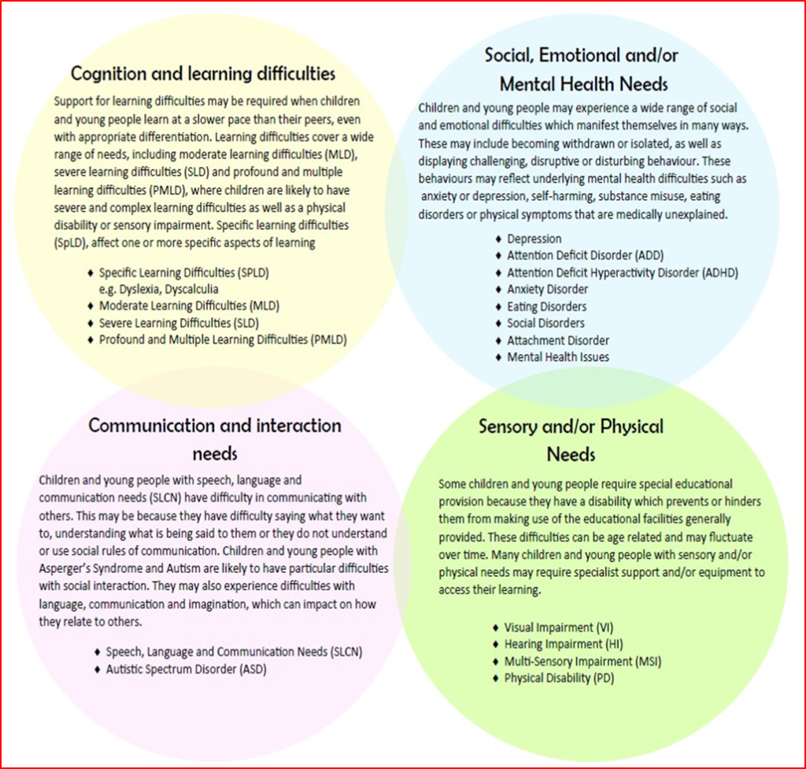
The four main areas of need
The Code of practice categorises SEND into 4 main areas of need. However, some of our learners with additional needs may find that they have differences in more than one area.

Who can help?
Who are the best people to talk to in this school about my child’s difficulties with learning/ Special Educational Needs/Disability (SEND)? And how can I talk to them about my child if I need to?
Class teacher | SEND responsibilities:
(s/he is recommended as the first point of contact if you have any concerns).  The class teacher can be contacted by speaking to them at the end of a school day to arrange an appointment or messaging the school through Arbor and asking for a message to be left with the class teacher. | • Making sure that all children have access to good/outstanding teaching and that the curriculum is adapted to meet your child’s individual needs (also known as personalisation or differentiation).  • Checking on the progress of your child and identifying, planning and delivering any additional help your child may need (this could be things like targeted work, additional support, adapting resources etc.) and discussing amendments with the SENCo as necessary.  • Writing Individual Provision Maps (IPMs) and reviewing these regularly by liaising with Teaching assistants involved in specific interventions.  • Planning appropriate intervention to support children effectively.  • Taking responsibility for demonstrating the impact of provision and pupil progress.  • Making sure that all members of staff working with your child in school are aware of your child’s individual needs and/or conditions and what specific adjustments need to be made to enable them to be included and make progress.  • Making sure that all staff working with your child in school are supported in delivering the planned work/programme for your child, so they can achieve the best possible progress. This may involve the use of additional adults, outside specialist help and specially planned work and resources.  • Making sure that the school’s SEND Policy is followed in their classroom and for all the pupils they teach with any SEND.

The SENCo- Miss Joynes (YR-Y3) Mrs Colcombe (Y4) | SEND responsibilities:
The SENCo can be contacted by: asking the class teacher to arrange for them to contact you, or by messaging the school on Arbor to make an appointment. | • Coordinating all the support for children with Special Educational Needs and or Disabilities (SEND) and developing the school’s SEND Policy to make sure all children get a consistent, high-quality response to meeting their needs in school.  • Making sure that class teachers are supported to ensure that you are:  - Involved in supporting your child’s learning.  - Kept informed about the support your child is receiving.  - Involved in reviewing how they are progressing.  - Involved in planning your child’s support.  • Providing support for teachers and support staff in the school so they can help your child (and other pupils with SEND in the school) to achieve their potential.  • Organising training for staff so they are aware and confident about how to meet the needs of your child and others within our school.  • Supporting your child’s class teacher to write Individual Provision Maps that specify the targets set for your child to achieve. These are then reviewed in termly meetings between the SENCo and parents.  • Liaising with outside agencies who may be coming into school to help support your child’s learning e.g. Speech and Language Therapy, Occupational Therapist, Educational Psychology, Complex Communication Team. Then communicating their observations and recommendations with class teachers and parents.  • Updating the school’s SEND record of need, (a system for ensuring all the special educational, physical and sensory needs of pupils in this school are known and understood) and making sure that there are excellent records of your child’s progress and needs.  • Preparing an application for a statutory assessment for an Education, Health and Care Plan where needed.  • Managing the annual review for children with an Educational Health Care Plan.  • Ensure that regular written reports are given to the Head teacher for each report that is submitted to the Governing Body of the school.  • Ensure that the teachers in the school are aware of the importance of identifying and providing for pupils who have SEN and feel confident in following the procedure when initial concerns are raised.  • Report to and liaise with the Headteacher.

Support staff/ Teaching Assistants | SEND responsibilities:
Our Teaching Assistants provide support in a number of different roles:
• In class support, as well as providing support outside of the classroom for pupils with additional needs; at the Targeted Support Level. Every year group has dedicated time from a TA and is directed by the Class Teacher.
• Teaching Assistants may provide more personalised support to individual pupils in class. They may be allocated to work for short periods of time with an individual pupil with very complex special educational needs and/or disabilities but primarily work with a small group of pupils. All our TAs have accessed more focussed and specialised training from professionals such as a speech and language therapist, occupational therapist, complex communication needs team or Educational Psychologist.
• The SENCo provides TAs with The Whole School Provision Map which outlines specific interventions which are to be carried out to support pupils with various needs. Interventions provide specialist personalised support in a particular area, for example communication needs, or pupils with social and emotional needs. Specialist TAs have received further training and support from outside agencies and often undertake specific work with pupils following advice or specific programmes that these agencies have provided.
• Whilst TAs take a very valuable role in your child’s education, we would prefer that questions regarding your child’s learning and progress are directed to your child’s class teacher. The class teacher and SENCo are fully involved in any support offered and make the decisions, in conjunction with the parents, on the type of support and interventions. A child may receive support from a number of adults, and a conversation with the class teacher or SENCo will give you a fuller picture than may be obtained from a single supporting adult. Of course, as a school we welcome regular dialogue between parents and all staff on how a child’s day has been, and we do actively encourage this continued feedback.

The Headteacher- Mrs Colcombe | SEND responsibilities:
The Head teacher can be contacted by: telephoning the school for an appointment via the school office. | • The day-to-day management of all aspects of the school, this includes the support for children with SEND. She delegates responsibility to the SENCo and class teachers but is still responsible for ensuring that your child’s needs are met and that they make the best possible progress.  • She must make sure that the Governing Body is kept up to date about all issues in the school relating to SEND.

SEND Governor- Mrs Wnuk | SEND responsibilities:
Contacted by: writing to the SEND Governor via the school office. | • Making sure that the school has an up to date SEND Policy. At The Vaynor First School the SEND Policy forms part of the school’s information report or ‘school offer’.  • Making sure that the school has appropriate provision and has made necessary adaptations to meet the needs of all children in the school.  • Making sure that the school’s SEN funding is appropriately spent.  • Making sure that the necessary support is made for any child who attends the school who has SEN and/or disabilities.  • To support and challenge the Head Teacher and SENCo with regards to SEN/D within the school.  • Making visits to understand and monitor the support given to children with SEND in the school and being part of the process to ensure your child achieves his/her potential in school. Our SEND Governor meets with our SENCO termly to ensure they are fully informed about inclusion within Vaynor.

What does support look like at Vaynor?
At The Vaynor First School, we follow a graduated response. Below is a diagram that outlines how the graduated response works in school. If support put into place in a step is not resulting in the desired outcome, the support in the next step is put into place. It is important to remember that parents of SEND children in school are informed through all steps and encouraged to contribute and help support their child.

 | Wave one- the effective inclusion of all pupils in high-quality everyday personalised teaching. | Wave two- a specific, additional and time-limited intervention provided for some children who need help to accelerate their progress to enable them to work at or above age-related expectations. | Wave three- targeted provision for a minority of children where it is necessary to provide highly tailored intervention to accelerate progress or enable children to achieve their potential.
Cognition and learning difficulties | - Differentiated curriculum planning  - Pitched questioning  - Modelling of skills  - High expectations  - Success criteria  - 1:1 and group reading  - Guided writing  - Visual dictionaries  - Word mats  - ICT to support learning  - Writing frames  - Practical resources  - Learning displays  - Support from Teaching Assistant  - Different learning styles are adopted- visual/kinaesthetic/auditory.  - Strategies for Autistic Spectrum Disorder (ASD), Attention Deficit Hyperactivity Disorder (ADHD)  - Next steps in marking  - All children's progress and attainment is assessed and tracked throughout the year | - SPaG group (Spelling, Punctuation and Grammar)  - Rapid reading  - Little Wandle catch up/keep up intervention  - Task boards to break down tasks into manageable chunks  - Precision Teaching  - Pre-teaching of vocabulary | - Intense (1:1) support in core and foundation subjects  - Targeted work from – Speech and language therapist  - Support from Educational Psychologist  - Clicker Sentences
Social, emotional and/or mental health needs | - Differentiated curriculum planning  - Whole school behaviour policy  - School & class rules  - PSHE planned lessons using Jigsaw  - Whole school assemblies  - Class assemblies planned using My Happy Mind  - Talking partners  - Class visual timetable  - Visual reward systems  - Class point system  - Time out in a safe place  - Timers & stress relievers  - Emotion/social resources  - Positive touch  - praise and high expectations  - Superpower certificates  - Class Monitors, School council  - Fiddle objects | - Talk about group (social skills & self-esteem)  - Individual reward system & behaviour logs  - Additional support at breaktimes  - Transition support- Now/Next visual  - Individual social stories to teach specific social skills  - Involvement from the Family Support Worker (FSW) | - 1:1 Emotional Literacy Programme (ELSA)  - Play therapy programme  - Individual work station  - Targeted work from –Behaviour Support, CAMHS and/or Educational Psychologist.
Communication and interaction needs | - Differentiated curriculum planning  - Modelled speech/language  - Modelled Interaction  - Targeted questioning  - Talking partners  - Group work  - Whole class circle time  - Class visual aids and prompts  - Visual timetables  - Key words/word banks  - Drama activities  - Sequencing activities  - Additional processing time  - Simplified Language  - A range of questions used so children develop and give clearer answers  - Opportunities for individual, pair, group or whole class working  - Regular communication through informal and formal meetings eg. parent’s evening  - Class and special assemblies  - Role play and Drama | - Pre-teaching of vocabulary  - Talk about group (social skills & self-esteem)  - Communication activities as advised by Speech and Language therapist.  - Colourful semantics programme  - CCN involvement | - Individual visual timetables  - Individual visual communication system  - Targeted work from Speech and Language therapy  - Targeted support from CCN team  - Speech and Language Therapy blocks
Sensory and/ or physical needs | - Differentiated curriculum planning  - Adaptions to the classroom (when appropriate)  - Fine motor skill activities such as: peg boards, putty, cutting etc.  - Additional movement breaks  - School building is accessible for all  - Classrooms have age-appropriate furniture and environments  - Visual prompts, pictures and ICT used appropriately to aid learning  - High quality resources are readily available, organised to enable independence  - Seating plans or group tables are used  - Lesson organised to maximise active learning providing time for concentration, discussion, thinking, reflecting and questioning.  - Outdoor learning opportunities | - Use of specialist equipment  - Pencil grips  - Coloured overlays  - Lap weights  - Sloping boards for desks  - Adapted cutlery.  - Fidget kits  - Paediatric Occupational Therapy assessment & resource pack  - Gross motor programmes SMART moves and JUMBO fun)  - Balance ball  - Trim trail  - Fine motor programmes | - Individual workstation  - Social stories  - Comic Strip Conversations  - Targeted work from Occupational Therapy  - Physiotherapy, Outreach Team  - Individual support with self-care where appropriate  - ICT program to develop keyboard skills.

How does the school identify if a child has special educational needs?

At The Vaynor, the progress of all children is closely tracked and monitored by all staff. This is currently done six times per academic year, the results of which are analysed by the Senior Leadership Team. Many pupils may experience a delay in their learning at some point and don’t make expected progress for a variety of reasons. Many will have differentiated work prepared for them by their class teacher. Following half-termly tracking there may be evidence that certain children are making less than expected progress despite class intervention (Wave one) and they may be referred to the SENCo who will advise and support the class teacher in implementing strategies in the first instance. Parents will be informed at this point. If it is felt that there are special educational needs in one of the four areas
I. Communication and Interaction
II. Cognition and Learning
III. Social, mental and emotional health
IV. Sensory and/or physical
then the school will follow the graduated approach, informing parents that their child will be placed on the school’s SEND register and will receive support at SEN Support level and external agencies will be consulted. An individual provision map (IPM) will be drawn up which will include SMART targets that will be regularly reviewed.
If you have concerns about your child’s progress or think they may have special educational needs, make an appointment to meet with your child’s class teacher and SENCo so your concerns can be listened to and appropriate actions can be agreed. Speaking to your school nurse or GP may also be a useful point of contact.

The graduated response
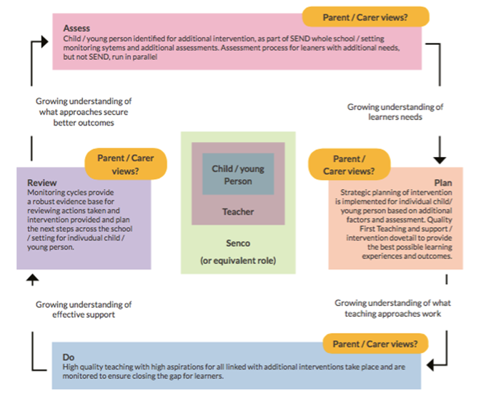

Educational Health Care Plan
For some children/young people there will be a need to target higher level support or more intense interventions as part of the graduated response. For most a cycle of changing intensity to allow generalisation and reinforcement will achieve progress and increase the child/young persons and teacher confidence. It will enable realistic assessments of what the child/young person can achieve and therefore influence projections about progress, performance and outcomes.
Occasionally the level of targeted support during the continuous spiral of Assess, Plan, Do, Review (which is the basis of all teaching for all children/young people) will need a longer term and maybe permanent increase. This may lead you to consider that an EHC assessment is needed to:
- Reflect on the arrangements that the setting has made and judge whether the setting should or could have developed the graduated response more effectively.
- Secure additional support so that the setting can sustain the child/young person within school following a provision programme that stands out as being significantly different to what is available for other children with SEND in school.
An EHC Plan is therefore more of the same, it has its own continuing graduated response approach, is guided by an outcome’s framework determined by the LA and provides schools with very clear and prescriptive guidance about how they must deploy their resources and support the child/young person. The annual review will reflect on the extent to which the setting has properly delivered the provision and secured outcomes that have been drawn from professional advice.

How will my child be included in activities outside the classroom including school trips?

We aim to ensure that all children are fully included in all aspects of school life including extra-curricular activities and school trips. All children are invited to take part in after school clubs and where clubs are run by external providers, these are run by coaches who are familiar with the children from delivering in school PE sessions each half term. Additional visits prior to residential trips (Y4 PGL) if deemed appropriate can be arranged. Where appropriate, additional adult support can also be arranged to support specific trips, including additional transition visits to Middle Schools. Parents are fully informed with such decisions and are also involved in supporting their children in preparing for school trips and their transition to Middle Schools.

How will the school prepare and support my child to join, or transfer to a new school?

Preparation for the transfer to Middle School happens in the Summer term but links between the main middle schools start in Year 3 with events such as Science and Drama days. Additional pre-transition visits are arranged for children with Special Educational Needs as well as children with English as an Additional Language and other children who may benefit. We ensure that at least one member of the Year 4 team accompanies those children on these additional pre-transition visits as they take photos of the new environment and key members of staff, support the children with any questions or concerns they have and record any notes about their memories of the day.
Parents are fully informed with such decisions and are also involved in supporting their children in preparing for their transition to Middle Schools as they are asked to complete a transition passport in preparation for this. Meetings are held in the Summer term between our SENCo and the SENCo from the transfer school to ensure consistency of provision is in place. Where a child has an EHC Plan, the SENCo and any additional staff member from the new placement are invited to attend the Annual Review. Where an Education and Health Care Plan requires support staff, the assigned member of staff from the new placement is welcomed into school to build relationships in advance of the transition. All of the information regarding your child’s needs is transferred to their new school with all SEN reports placed in separate discrete files for the attention of the SENCo at the Middle school placements.

Where can I find more information?

The Local Offer
What is the Local Offer? Every local authority must publish a Local Offer. The Local Offer tells you what support is available for children and young people with special educational needs (SEN) and/or disabilities, and their families. It should include information about education, health and care provision.
SEND Local Offer | Worcestershire County Council

