
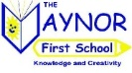
Year 3 Curriculum Plan – Summer Term
Yabba Dabba Doo!
Enquiry based topic question: “Which Stone Age Era would you be able to survive?”

English | Our Key Texts:  Stone Age Boy  By Satoshi Kitamura  How to Wash a Woolly Mammoth  by Michelle Robinson  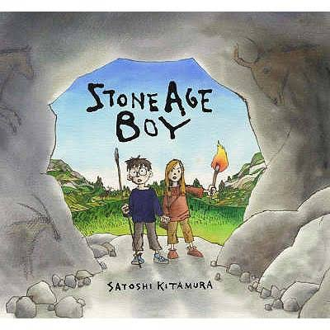  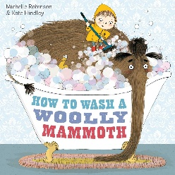 | Maths
This term, the children’s text will be Stone Age Boy and How to Wash a Woolly Mammoth. The children will be writing their own time travelling story and instructional writing.  Linking to these texts, the children will:  - Use effective vocabulary to empathise with the mood of a character.  - Develop writing through oracy.  - Write diary entries and letters from the perspective of different characters.  - Punctuate dialogue correctly.  - Role play and drama.  - Spelling focus – plurals, apostrophe as a possession.  - Writing in the correct verb tense.  - Write a set of clear instructions for washing a stone age animal.  - Write a narrative set in the past showing time travel. |  | As mathematicians, the children will learn:  To understand position and direction:  - To recognise that angles are a description of turn.  - Recognise that 2 right angles = half turn, three = three-quarter turn and four = full turn.  - Identify right angles within 2D shapes.  - Identify whether angles are greater than or less than a right angle.  To understand the properties of shapes:  - Identify: vertical, horizontal, parallel and perpendicular lines.  - Draw 2D Shapes – polygons.  - Recognise and describe 2D shapes.  - Recognise and describe 3D shapes.  - Make 3D shapes and recognise them in different orientations  To use measures:  - Measure the perimeter of simple 2D shapes.  - Tell and write the time from an analogue clock to the nearest minute.  - Tell the time using roman numeral and digital clocks (including am/pm)  - Record understand and compare units of time.  - Compare duration of events.  - Measure: length (mm,cm and mm) weight (g and kg) and volume (ml and l) accurately.  - Compare: length (mm,cm and mm) weight (g and kg) and volume (ml and l) accurately.  - Add and subtract: length (mm,cm and mm) weight (g and kg) and volume (ml and l) accurately.
Our Whole Class Reading Text:

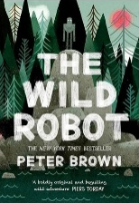
We will be reading The Wild Robot by Peter Brown.
Science | Personal, Social and Health Education | Physical Education
Light:  The children will learn:  - That we need light in order to see things .  - Darkness is the absence of light.  - Light is reflected onto surfaces.  - Light from the sun can be dangerous and how to protect ourselves.  - Shadows are formed when light is blocked.  - Why the length of shadows change throughout the day. | Relationships:  - To know how to make friends.  - To be able to solve friendship problems.  - To help others feel part of a group.  - To show respect to others.  - To know how to help themselves and others when they feel hurt.  - To know and show what makes a good relationship.  Changing Me:  - To understand everyone is unique.  - To express how they feel when change happens.  - Understand and respect the changes that they see in themselves.  - Understand and respect the changes that they see in others.  - To know who to ask for help if they are worried about change.  - To look ahead at changes to come. | Tennis:  The children will learn how:  - to use the ready position to return a ball.  - to hit the ball to different parts of the court using a forehand hit.  - to perform an underarm serve to start a rally.  - to move towards a ball to return it over the net.  - to play cooperatively with a partner to keep the ball moving over the net.  - to perform forehand hits to score points in a competition.  Rounders:  The children will learn how:  - to get into the best body position to field a ball.  - to bowl with some consistency in a game.  - to hit a moving ball with one hand.  - to stop a moving ball with the long barrier technique.  - to throw longer distances using the overarm technique.  - to select and apply new skills in a competition.
 | Religious Education | Modern Foreign Languages
 | What kind of world did Jesus want?  The children will learn:  - That ‘Gospel’ means ‘good new’.  - That Jesus had disciples.  - That Jesus wanted a world where people showed “love for all”.  - That churches and church leaders show love for people in different ways.  How and why do people try to make the world a better place?  - That religions suggest that people need help and guidance to live in the right way.  - That the ‘Golden Rule’ means you should treat others the way you want to be treated.  - That there are inspirational people and organisations which inspire people to make the world a better place. | The children will orally learn:  - Animals-Our pets  - How to order food in a cafe  Additionally, they will:  - Sing along to songs to help consolidate their understanding.  - Actively engage in language activities and tasks, developing the capacity to understand spoken language.
Computing | History | Art and Design
Presentations:  - To learn how to open PowerPoint, add text and change how it looks.  - To learn how to add slides, change slide designs and insert pictures into a presentation.  - To add animations to pictures and text, and transitions between slides.  - To create an effective presentation.  - To complete and present a slideshow to an audience.  Touch Typing:  - To learn correct finger positioning on the keyboard and understand when to use the left or right hand.  - To learn how to type numbers accurately and to use the shift key for capital letters.  - To practise typing punctuation marks and symbols and build accuracy with simple words.  - To practise typing sentences using capital letters, spaces, and full stops. | Which Stone Age era would you be able to survive?  The children will learn:  - That the Stone Age lasted around 2.5million years and consisted of 3 different periods – Palaeolithic, Mesolithic and Neolithic.  - The Stone Age lasted from approximately 13,000BC to 4000BC.  - During the Neolithic, people began to create and settle in villages such as Skara Brae.  - Settlements were chosen to enable them to still hunt for food and farm.  - The Bronze Age came after the Stone Age in which the discovery of bronze was used to make hunting tools. Humans also began to farmland.  - The Iron Age came after the Bronze Age in which humans discovered and used iron to make tools and farmed lands instead of hunting. They began to live in communities. | Sculpture:  Focus artist: Joan Miro  The children will:  - Make a 3D sculpture.  - Combine different shapes and materials to create texture.  - Join 2D shapes to make a 3D form.  - Join larger pieces of materials, exploring what gives 3D shapes stability.  - Shape card in different ways eg. rolling, folding and choose the best way to recreate a drawn idea.  - Identify and draw negative spaces.  - Plan a sculpture by drawing.  - Choose materials to scale up an idea.  - Create different joins in card eg. slot, tabs, wrapping.  - Add surface detail to a sculpture using colour or texture.
Music | Design and Technology | Geography
Charanga – The Dragon Song/Bringing Us Together  The children will learn:  - To confidently identify and move to the pulse.  - To think about what the words of a song mean.  - To follow a leader when singing.  - Play any one differentiated part on a tuned instrument  - To rehearse and perform their part within the context of the song.  - Plan and create a section of music that can be performed within the context of the unit song. | Structures  The children will be making helmets.  Design:  - Use research and develop design criteria to inform the design of innovative, functional, appealing products that are fit for purpose, aimed at particular individuals or groups.  - Generate, develop, model and communicate their ideas through discussion, annotated sketches, cross-sectional and exploded diagrams, prototypes, pattern pieces and computer-aided design.  Make:  - Select from and use a wider range of tools and equipment to perform practical tasks [for example, cutting, shaping, joining and finishing], accurately.  - Select from and use a wider range of materials and components, including construction materials, textiles and ingredients, according to their functional properties and aesthetic qualities.  Evaluate:  - Investigate and analyse a range of existing products.  - Evaluate their ideas and products against their own design criteria and consider the views of others to improve their work.  - Understand how key events and individuals in design and technology have helped shape the world.  Technical Knowledge:  - Apply their understanding of how to strengthen, stiffen and reinforce more complex structures. | What Are the Orkney Islands Like?  The children will learn:  - To locate Orkney Islands on maps and globes.  - To describe some key features of the Islands such as; climate, population, topography.  - To locate Skara Brae in the Orkney Islands.

