
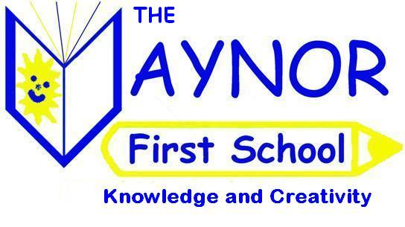
THE VAYNOR FIRST SCHOOL
FORM A

Parental Agreement for the Administering of Medicine

School will not give your child medicine unless you complete and sign this form. Medication will be administered in line with school policy.

Child’s name:

Date of birth:

Class:

Medical condition or illness:

MEDICINE – NOTE: Medicines must be in the original container as dispensed by the pharmacy

Name/type of medicine:
(as described on the container)

Expiry date:

Dosage and method:

Timing:

CONTACT DETAILS:

Name of parent or adult contact:
(in case of problems with medication)

Daytime telephone number:

Relationship to child

I understand that I must deliver and collect the medicine personally to/from the school office.

I accept that this is a service that the school is not obliged to undertake.

Date: __________________ Signature: __________________________

